PART I. PROJECT IDENTIFICATION
Project Name: Unique name or alphanumeric identifier associated with the project. For example, “Anzac01 FireSmart Mulch Project”.
Date: Year, month and day the prescription was completed. For example, 2014-01-13.
Latitude/Longitude: Use GPS coordinates for the general treatment location.
Distance and Azmuth from Project Boundary to Nearest Occupied Dwelling: Use kilometres and compass azimuth (0 to 360 degrees) to the nearest occupied dwelling. For example, 0.50 km at 245 degrees.
Plot
One plot per representative fuel type is required.

Plots should cover the entire project area. The grid must capture all of the Canadian Forest Fire Danger Rating System fuel types within the project area.
If the project area is broken by roads, dwellings and other man-made developments, the project area will be considered separate project areas.
If the project area is seperated by fuel/timber type changes, water bodies or other natural developments, it will be considered one project area.
For example, a 12 hectare project area is broken into a 2 hectare area and a 10 hectare area by a row of houses and a road. This creates two project areas requiring 7 plots total (10 ha [4 plots] and 2 ha [3 plots]).
If the same area was broken by a D-1 fuel type or a river, it would be considered one project area of 12 hectares and require 5 plots.

PART II. PLOT DATA SHEETS
A plot data sheet is to be completed for each plot. Fill in the appropriate plot number.
- PHOTOS: Photographs North (0 degrees), South (180 degrees), East (90 degrees) and West (270 degrees) are to be taken from the plot centre. A representative photograph of the forest floor in the plot is to be taken. Photos are to be labelled with the project name, date, plot number, latitude and longitude and direction (N, S, E, W). Photos are to have an accuracy of +/- 3 metres from the plot centre. Compass declination must be appropriately set for the location.

- PLOT TALLY: A 3.99 metre plot cord tally of all trees that fall within the plot boundary is to be recorded. One average height and one diameter (DBH at 1.3 metres above ground level) for each tree species in the plot is to be taken. Height is to be recorded to the nearest metre and diameter to the nearest even numbered 2 centimetre class for trees which are 10 centimetres or over. If the trees are under 10 centimetres , diameter is to be to the nearest 0.1 centimetre.

Live crown base height is measured as the height above ground of the lowest live branches on the tree to the nearest 0.5 metre.

Tally is to be completed using a dot tally format.

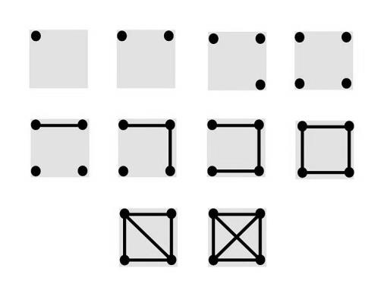

- PLOT AVI (Include understory if present.) AND CANADIAN FOREST FIRE BEHAVIOUR PREDICTION (FBP) FUEL TYPE:
See: http://esrd.alberta.ca/lands-forests/vegetation-inventory-standards.aspx to review documents on AVI type calls.

Refer to the Field Guide to the Canadian Forest Fire Behavior Prediction (FBP) System for fuel types. Guide is available at: http://cfs.nrcan.gc.ca/publications?id=25139 .

- GROUND COVER DATA:

Estimate plot percent ground cover for coarse woody debris ≥ 7cm in diameter. Tally the number of pieces within the plot.

If a coniferous understory layer is present, identify the dominant species and estimate the percent ground coverage of the understory layer within the plot.

Provide measurements for the following ground cover layers in centimetres. The intent is to best measure these layers at a point in the plot without establishing a soil pit.

Forest Floor/Litter Layer: This layer consists of the fine woody debris, coarse tree needles and green moss.

Upper Duff Layer: Consists of the brownish lower portions of moss and partly decomposed matter.

Lower Duff Layer: Consists of decomposing organic matter. If layer is greater than 20 cm, record only as 20 cm +.

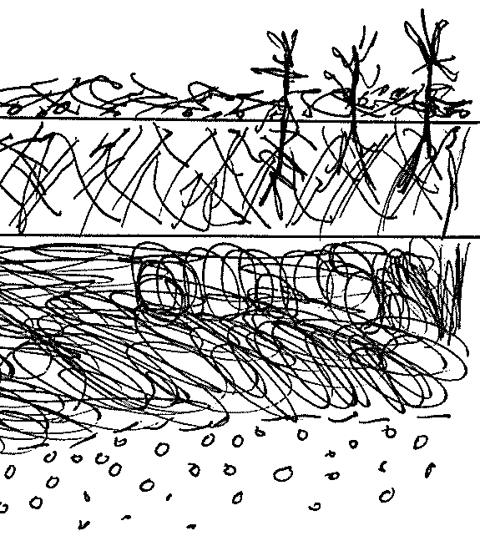
Forest Floor/Litter Layer
Mineral Soil
Lower Duff Layer
Upper Duff Layer

- ECOSITE CLASSIFICATION AND SITE EVALUATION: Based on the appropriate Field Guide to Ecosites of Southwestern Alberta, Northern Alberta or West-central Alberta. These guides are available at http://cfs.nrcan.gc.ca/publications. Each guide contains a brief description on how to apply the classification.

Rutting Hazard, Soil Compaction Potential and Comments: Provide information as to the potential for rutting and soil compaction during the season of operations. For example, Site is mesic (high water table). There will be rutting concerns if operations occur outside of frozen ground conditions.

Refer to: http://esrd.alberta.ca/lands-forests/forest-management/forest-management-manuals-guidelines.aspx for specifics regarding timber harvest planning and operating ground rules.

Potential Watercourse/Water Table Issues: Classify any watercourses on site and identify any crossings necessary to access the site. Comment on any potential water table issues anticipated when the canopy layers are altered.

Refer to: http://esrd.alberta.ca/lands-forests/forest-management/forest-management-manuals-guidelines.aspx for specifics regarding timber harvest planning and operating ground rules.

General Forest Health (Insects, Diseases and Weeds) Comments: Comment on the health of the stand and site in terms of any observable forest insect damage, diseases and noxious or restricted weeds.

Refer to: http://esrd.alberta.ca/lands-forests/forest-health/default.aspx for general forest health information.
PART III. PRESCRIPTION SUMMARY
To be completed once for the entire project.
- RECOMMENDED TREATMENT: To include type of treatment (logging, thinning, pruning, mulching, selective harvest, etc. and mechanical or non-mechanical) Include suggested equipment (mechanical) and recommended ground conditions for treatment (frozen or non-frozen).

Include specifics as to crown spacing, pruning height, type of equipment, etc.
2. DEBRIS MANAGEMENT STRATEGY: Include debris management method (mulch, pile/burn, haul off site, lop/scatter, etc. and recommended post treatment debris levels (percent ground cover).
Include as much information as possible—such as timing for burning piles, depth of mulch, etc.
3. EXPECTED POST TREATMENT VEGETATION RESPONSE: Comment on potential regeneration (deciduous and coniferous) as well as grass/shrubs/forbs response to the treatment. For example, grass ingress is expected in the next two years. On-site mulch will likely reduce the grass ingress.
4. PROPOSED MAINTENANCE STRATEGY AND SCHEDULE: Hazardous fuels management treatments will at some point require maintenance. Identify the maintenance method and the approximate time intervals for the maintenance.
PART IV. PRESCRIPTION SIGN OFF AND SUBMISSION
ATTACHMENTS: Map (mandatory): A map is to be submitted with each prescription showing at minimum the following:
- Boundary of the project
- Survey grid and plot locations
- Watercourses (if applicable)
- Access
- Community boundary/residential lot boundaries of the project
- Land ownership
All plot cards completed for the project area.
Photographs as specified for the plots.
Land titles search showing the ownership class for the project area.
Other applicable information – specify. This could include letters of endorsement, wildfire threat/fire behavior information, etc.
SIGN-OFF AND SUBMISSION: Name, signature and registered professional forester/registered professional forest technologist number or stamp is required. If a regulated forestry professional supervised the completion of the work of a non-regulated individual, the regulated professional’s stamp/signature will be required.
Submit one copy of this prescription to the local Agriculture and Forestry Wildfire Management Area office and one copy to the address listed on the form.
Questions and Feedback: Please Contact Wendell Pozniak, FireSmart Forest Management Specialist, Wendell.Pozniak@gov.ab.ca, 780-644-7164.

